Resolução ficha 3 CS -

Pedro Perdigão A47701, Afonso Correia A47521, Ahmet Duran A48095, Diogo Justino A47694

2.1

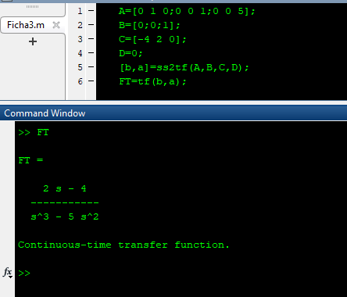

3.1

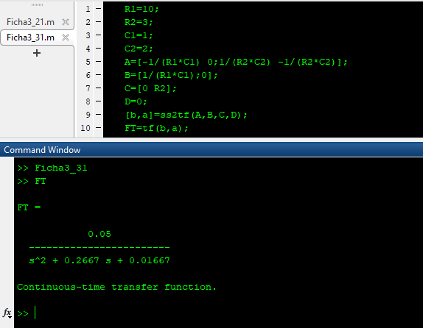

4.1

5.1

